**PROJECT REPORT**

**Datasource:-**

* We obtained the dataset from the Kaggle platform. The link to the website is Data extracted from the Highway Traffic Safety Administration (NHTSA) regarding car accidents  <https://www.nhtsa.gov/file-downloads?p=nhtsa/downloads/FARS/>
* The Dataset contains data about the U.S. accidents in various states.

Descriptive Analysis:-

**Classification tree:**

* 74.49% of accidents have happened in clear weather and 0.04% of accidents in Sleet or hail weather.
* 74.49% of accidents have happened in Dark or non lighted area.
* The most number of accidents have taken place from month of January to December.
* Out of which 65.69 % were on clear weathers. 9.25% were in rainy weathers.
* From Month of June to December most of the accidents were in Clear weather and least in snowy weather.
* The most important is not much of the accidents have taken place in rainy weather.

* As Texas and California has most number of accidents and New York has the least.The most of the accidents in Texas and California were in clear and cloudy weather where as in New York.In New York accidents have taken place in Snow also.In New York most of the accidents have happened in Inner city roads and not on outer roads where cars tends to be fast.The most important is less numbers of accidents have taken place during fogs.

**Classification tree and factor analysis Diagrams:**

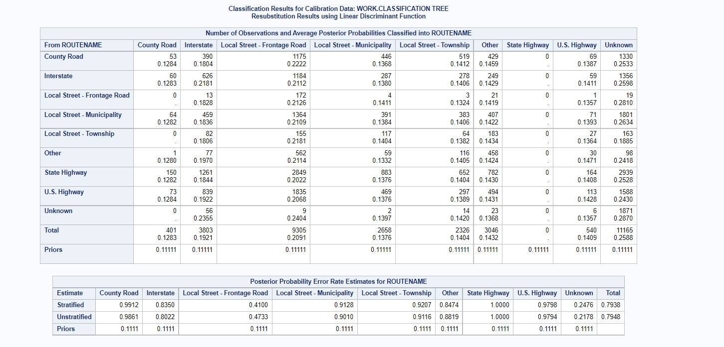

Factor Analysis report:

* In fact 1 state and st_case have the largest positive loadings.In fact 2 Minute and Hour have the largest positive loadings.In fact 3 Persons has the largest and route is having smallest loadings.In fact 4 drunk _dr have the largest and the milept have the smallest loadings.In fact 5 milept has the largest and hour has smallest loadings.In fact 6 hour and persons has the largest loaidngs.In fact 7 persons and route has the largest loadings.In fact 8 typ_intname has the largest loading.In fact 9 minute has the largest loadings.

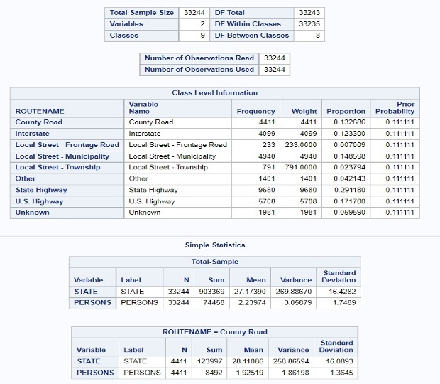

**Results and caveats:**

Hereby it is declared that, 74.49% of accidents have happened in clear weather and 0.04% of accidents in Sleet or hail weather.

* 74.49% of accidents have happened in Dark or non lighted area.
* The most number of accidents have taken place from month of January to December.
* Out of which 65.69 % were on clear weathers. 9.25% were in rainy weathers.
* From Month of June to December most of the accidents were in Clear weather and least in snowy weather.
* The most important is not much of the accidents have taken place in rainy weather.

**Conclusions and implications:**

* Our aim is to implement, develop and assess road safety and find the key factors that are causing such accidents. Also, getting a better understanding of road operational problems and risk factors while considering the measures to minimize these problems.
* These findings and analysis will help us gain understanding of how road traffic operational problems by developing accurate diagnosis and remedial measures and evaluating the effectiveness of road safety. This can help road safety researchers and decision makers to adopt and produce different strategies for traffic and highway safety.